**Letter of Medical Necessity**

(Please Type on Physician’s Letterhead)

Date: _________

|  |  |
| --- | --- |
| Insurance Company: _____________  Address: _______________________  City, State, Zip Code: _____________ | Patient’s Name: _______________  Policy Number: _______________  Group Number: _______________  Date of Birth: ________________ |

RE: Letter of Medical Necessity for Helicoll

Dear [Insurance Contact Name]:

I am writing to notify you of my intent to treat the above-mentioned patient with Helicoll (Q4164) Skin Substitute using CPT __________ for the diagnostic ICD 10 code(s): ______, ______.

The patient history is documented in the previous treatments and noticed there is no significant improvement in the cure of the ulcer wound compared to the size of the wound first examined. The patient has not responded to conservative care and other advanced treatments which is maintained in the patient records.

It is my medical expert opinion to pursue the treatment using Helicoll. I have noticed the clinical case studies document the use of Helicoll to successfully treat chronic wounds that have not responded to the standard wound care and other advanced therapies. Helicoll can expedite the healing in shorter time with lesser number of applications. Thereby it benefits and comforts the patient which also saves the healthcare costs with lesser payment by the insurance.

I feel this request of using Helicoll is medically necessary and calls for urgent need to the patient, based on the product information provided below:

**Clinical and technical features of Helicoll** (from [www.helicoll.com](http://www.helicoll.com))**:**

* **High purity type-I Collagen:** Helicoll is a patented reconstituted bioactive collagen sheet, free of immunogenic proteins, lipids, and elastin.
* **Faster Healing:** Collagen phosphorylation attracts cells, regenerates tissue, and stimulates blood capillaries/granulation within 4 to 5 days. No other product shows this advantage in the clinical data.
* **Innovative Technology:** Better than intact tissue-based membranes like amnion, intestinal wall, urinary bladder, etc. which contain >15% elastin. Especially the recent reviews (see annex 1) document the alarming carcinogenic effects of elastin containing intact tissue membrane derived products.
* **Pain Control:** Helicoll is also clinically proven to reduce pain compared to other standards of care

In conclusion, we strongly believe you will agree with my medical expert opinion upon my complete and thorough review to allow for treatment with Helicoll. I welcome an opportunity to discuss this with you over the phone if necessary. Please feel free to contact me if additional information is required.

Thank you for your valuable time. I look forward to hearing from you.

Sincerely,

Physician Name

Contact Information

Required Documentation (See Annex-I)

**Annex – I**

**Helicoll Technical Info:**

1. Helicoll published Stanford Article (2015) <https://helicoll.com/wp-content/uploads/2024/03/Helicoll_published_Stanford_Article.pdf>

2. Shriners Hospital Burn Ctr Galveston TX (2013) <https://helicoll.com/wp-content/uploads/2024/03/Shriners_Hospital_Burn_Ctr_Galveston_TX.pdf>

3. Helicoll Clinical & Technical Features Audio-Visual <https://helicoll.com/images/Helicoll_AV_no_Distributor.mp4>

4. Encoll Tech Product for Electric Burn Wound <https://helicoll.com/wp-content/uploads/2024/12/Encoll-Tech-Prdt-Electric-Burn-Wound-21May2021.mp4>

5. White paper on Helicoll for Diabetic Foot Ulcers <https://helicoll.com/wp-content/uploads/2024/03/Helicoll-Diabetic_Ulcer_Usage.pdf>

6. Helicoll for Malignant Melanoma & DFU [https://helicoll.com/wp-content/uploads/2024/12/Encoll-Melanoma-DFU-24May2021.mp4](https://helicoll.com/wp-content/uploads/2024/12/Encoll-Melanoma-DFU-24May2021.mp4%20)

7. Helicoll Case Reports: https://helicoll.com/case-reports/

**Elastin Carcinogenicity:**

Please be aware of the alarming fact about the safety concerns of using an intact tissue membrane-based regenerative matrix.  They all contain 15% elastin in them which happens to be the culprit (Watch this excerpt from a Panel Discussion at the Society for Biomaterials 2021 [www.helicoll.com/video/Helicoll_SFB_Elastin.mp4](http://www.helicoll.com/video/Helicoll_SFB_Elastin.mp4)).

Examples of such products include intact membranes of

a. amnion (Amniofix, Epifix, Amnioexcel, Xwrap)

b. placenta (Grafix)

c. umbilical cord (Cellesta Cord)

d. pericardium (Architect from Equine)

e. urinary bladder (Cytal from Porcine)

f.  intestinal wall (Oasis from porcine SIS) and

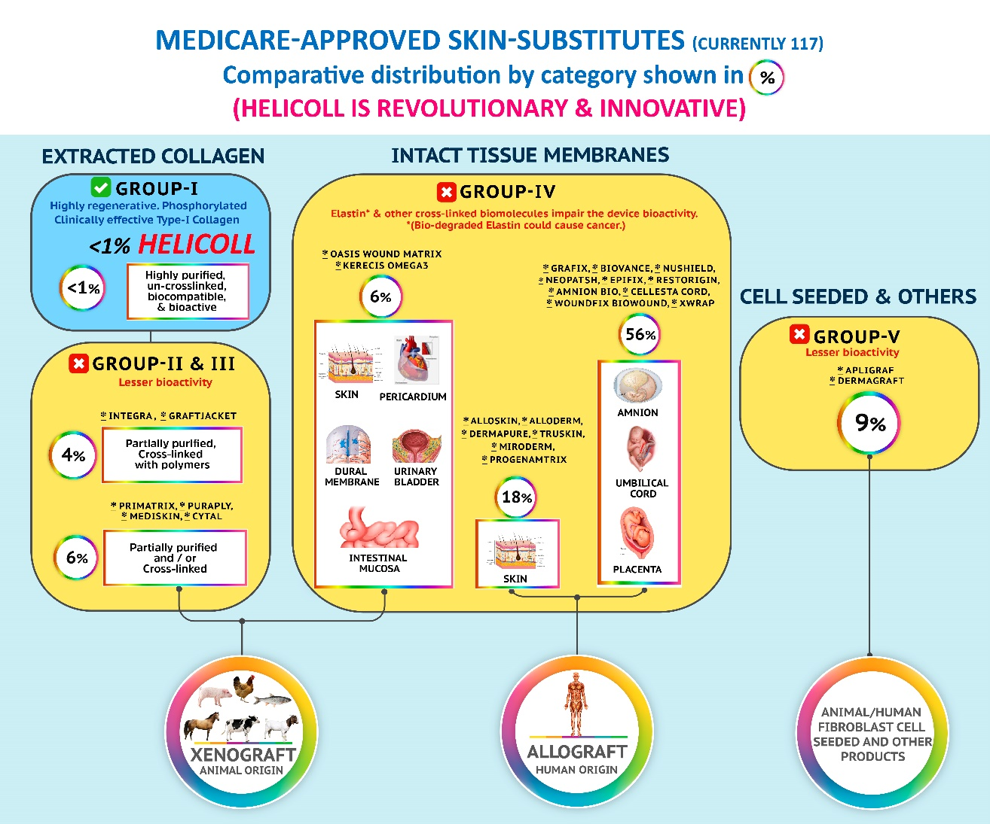g. skin (Kerecis from fish, EZ Derm from porcine, Apligraf from human)

The biological degradation of Elastin resulting in Elastomer/Elastokine fragments is proven to be carcinogenic [ref. [www.nature.com/articles/s41467-020-18794-x.pdf](http://www.nature.com/articles/s41467-020-18794-x.pdf)] and could cause various pathological conditions including emphysema, chronic obstructive pulmonary disease, atherosclerosis, metabolic syndrome, etc.

[ref. <https://www.tandfonline.com/doi/full/10.1080/10409238.2020.1768208>]. There is no successful elastin-based biomaterial available until now for tissue replacement/repair applications.

Several publications including the recent article in the Nature journal confirm the possibility of elastokines or the elastin-derived matrikines being carcinogenic.

Page 7 of this article given below is the evidence for the carcinogenicity of elastin:

*"On the other hand, various elastin-derived matrikines, such as Val-Gly-Val-Ala-Pro-Gly (VGVAPG) or Ala-Gly-Val-Pro-Gly-Leu-Gly-Val-Gly (AGVPGLGVG) promote tumor progression (Ref. 113). These ECM fragments are products of the degradation of elastin through different proteolytic enzymes (elastases) (Ref. 114) and MMPs (Ref. 115). These matrikines can, in turn, also induce MMP expression and activation, including MT1-MMP and MMP-2, which would explain their tumor-promoting properties (Ref. 116)"*

**Ref.** 113. Da Silva, J. et al. Structural characterization and pro-tumor properties of a highly conserved matrikine. Oncotarget 9, 17839–17857 (2018).

**Ref.**114. Werb, Z. et al., Elastases and elastin degradation. J. Invest. Dermatol. 79, 154s–159s (1982).

**Ref.**115. Mecham, R. P. et al., Elastin degradation by MMPs. J. Biol. Chem. 272, 18071–18076 (1997).

**Ref.**116. Brassart, B. et al., Regulation of matrix metalloproteinase-2 (gelatinase A, MMP-2), membrane-type matrix